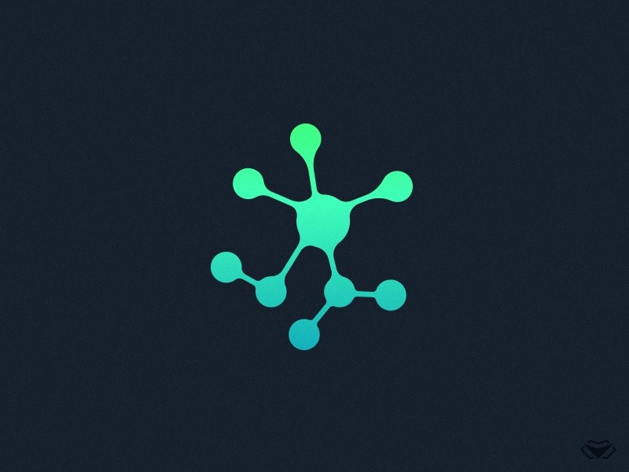

**TEAM 9 MEETING**

**MINUTES**

**Week 9 Group Meeting**

**Meeting Details**

|  |  |
| --- | --- |
| **Team Name:** | Team 9 |
| **Meeting Date:** | 13th October |
| **Time:** | 10:00-11:00 am |
| **Venue:** | Discord Online Meeting |
| **Attendees:** | Dhruv, Matthew, Josh, Dennis, Rodney |
| **Absent Members:** | Isaac |
| **Minutes Taker:** | Dennis |

**Agenda Details**

|  |  |
| --- | --- |
| Tasks | Sub-tasks |
| Discussions/Clarifications | * Discusses progress of each issue * Asks questions on problems each member might encounter |
| Next Meeting | * Share progress on assigned issues |

**Meeting Commences (10:00am)**

Dhruv asks about the group’s personal progress

Matthew has been trying to get the lighting right, and has been working in blender

Matthew Shows the group the progress he made on uv mapping

Dhruv Discusses on how the deadline is coming up soon, and encourages everyone to continue working hard on the issues assigned

Dhruv also encourages people to fill up the documentation files as well

Dhruv reminds people to take videos of the final product, 2 videos of two particles one charged and one uncharged

Dennis Mentions a problems he encountered regarding unity having no csv reader

Dhruv Recommends converting the CSV into a JSON, to integrate it easier to Unity

Dennis asks for suggestions on how the user will select the particles from the menu, as there are hundreds of different particles

Dhruv Suggests to hardcode some trial particles first, then move on to a scrollable list when the code could run well

Dhruv Asks to add charges and masses to the particle spawner, as they are currently just neutral

Matthew Asks if there needs to be documentation on the 3d model of the lab he is working on

Dhruv Feels that it would be nice to have documentation on that

Matthew [Agrees]

**Finishing at 11:00 am**